**SPRINT – 4**

|  |  |
| --- | --- |
| **Date** | 14-11-2022 |
| **Team ID** | PNT2022TMID51106 |
| **Project Name** | Hazardous Area Monitoring for Industrial Plants Powered by IoT |

**STEP 1 :**

Make a connection between the node functions in the node red application.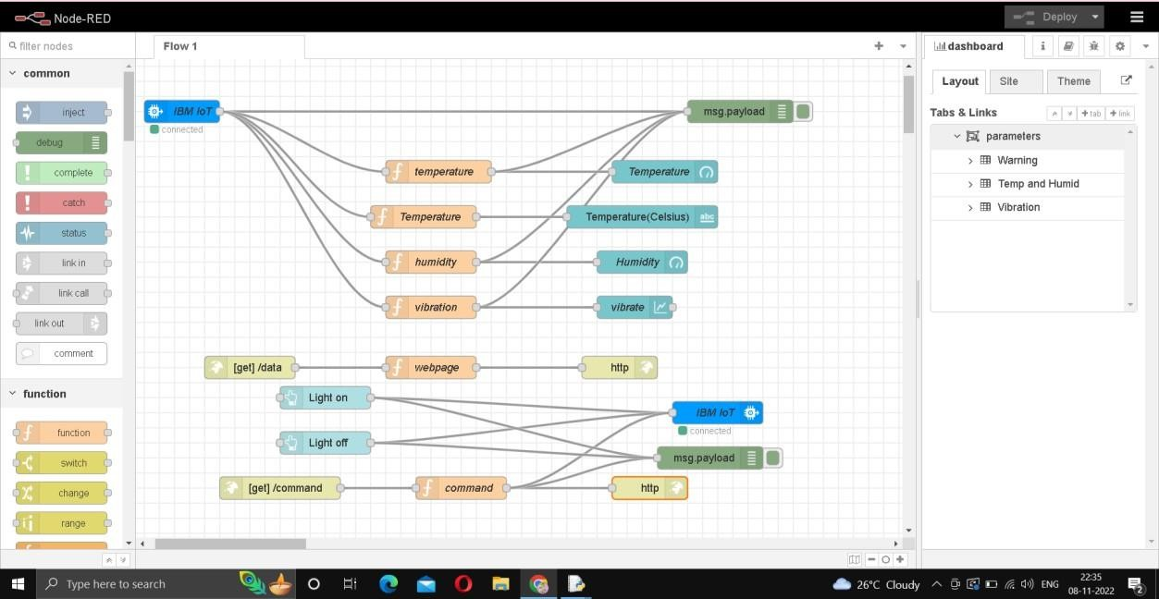

**STEP 2 :**

To view the Output view the node-red dashboard.

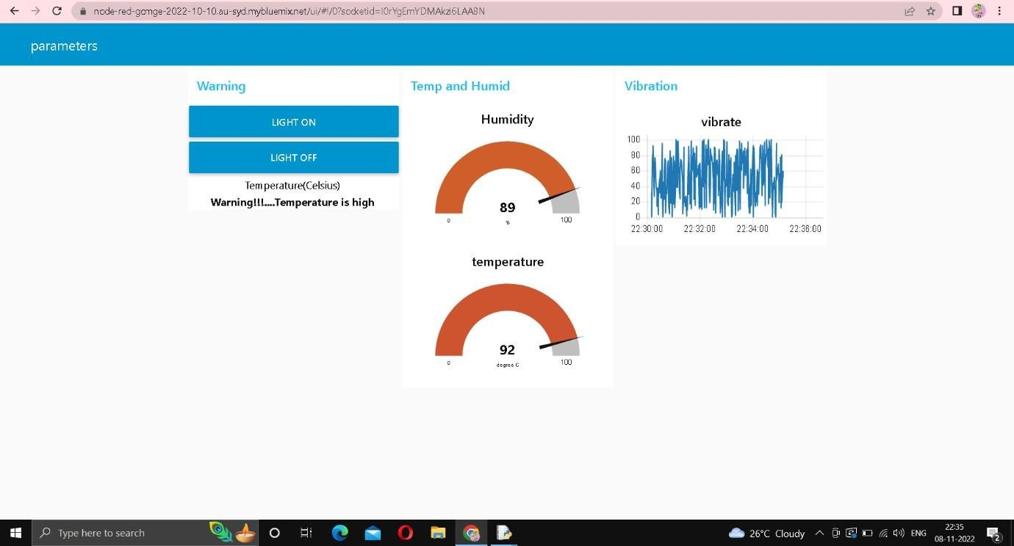

**STEP 3 :**

To view the web UI copy the link in the node red upto .net/ and type data and user can view the temperature , humidity and vibration.

